# Database Schema of ‘icstesto’

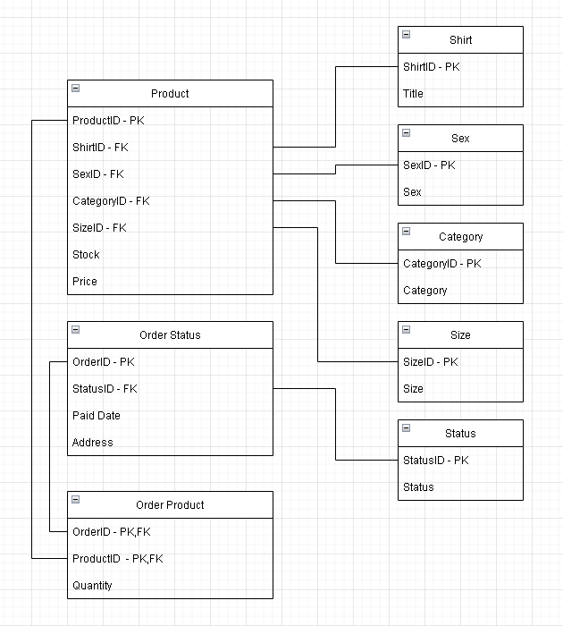

# Table Structs

Category Shirt

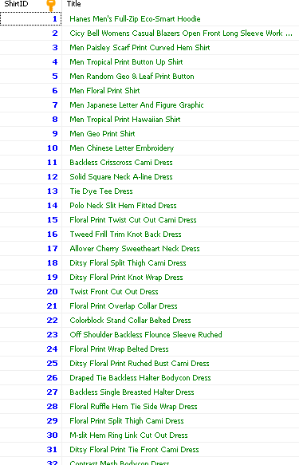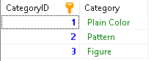

Sex



Size

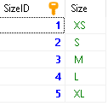

Status

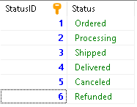

# Running

1. Install Nodejs
2. Clone project
3. Open terminal
4. npm install
5. *npm run start*

## API Explanations

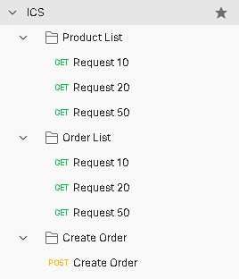Product List - Filter products by category, sex, and size. Developer can specify request count in param, any excess can be viewed in later pages.

Order List - Filter orders by payment date-range, and order status. Developer can specify request count in param, any excess can be viewed in later pages.

Order Create - Developer can post JSON containing address, productid and quantity.

**Product List**

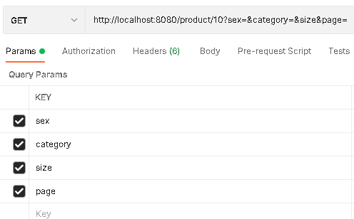

**Order List**

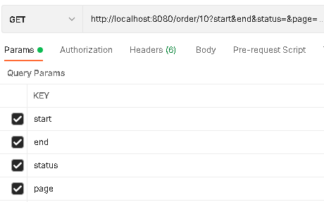

**Order Create**

